SECTION A (60 Marks)
Answer only three questions from this section.
- Distinguish between order of reaction and activation energy. (02 marks)

- The table below shows the concentration of iodine varying with time during the acid catalyzed iodination of propanone.
Time (mins) | 0 | 2 | 4 | 6 | 8 | 10 | 12
[I₂](mol/dm³) | 0.210 | 0.190 | 0.166 | 0.150 | 0.134 | 0.110 | 0.090
- Plot a graph of iodine against time and use it to determine: (03½ marks)
- Units. (01½ marks)
- The order of reaction. (02 marks)
- Describe an experiment to show the results in (b) can be determine. (06 marks)
- Ethanol decomposes thermally to form methane and carbon monoxide according the following equation.
Standard enthalpy of formation are ∆H_{f}^{θ}[CH₃CHO] = ⁻166kJ/mol.
∆H_{f}^{θ}[CH₄] = ⁻75kJ/mol & ∆H_{f}^{θ}[CO] = ⁻110kJ/mol
The activation energy,Ea = ⁺190kJ/mol
Draw the reaction profile for the reaction indicating the values of Ea and H^{θ}_{reaction}. (05 marks)

- An organic compound, P C₆H₁₂O₂ has the following properties.
- It forms a yellow precipitate with both Brady’s reagent and iodine solution in presence of sodium hydroxide solution.
- It burns with yellow non-sooty flame.
- It forms a cloudy solution immediately when treated with concentrated hydrochloric acid in presence of anhydrous zinc chloride.
- Write structural formula and IUPAC name of organic compound, P. (02 marks)
- Write equation and suggest a mechanism for the reaction between organic compound, P and:
- Concentrated hydrochloric acid in presence of anhydrous zinc chloride. (03½ marks)
- Hot concentrated orthophosphoric acid at 160ᵒC. (04½ marks)
- Potassium cyanide in the presence of dilute sulphuric acid at the temperature less than 20ᵒC. (03 marks)
- Brady’s reagent. (05 marks)
- Using equations only, show how organic compound, P can be synthesized from propan-2-ol. (02 marks)

- The boiling points of hydrides of group (IV) and (VII) are shown in the graph below.
- Explain why:
- The graph for hydrides of group (IV) is almost linear. (02½ marks)
- The boiling point of the hydride of fluorine is abnormally high compared to that of the hydride of carbon. (03½ marks)
- The boiling points of other hydrides of group seven elements increase with increase in period number. (02½ marks)
- Describe the reactions of:
- Hydrides of group (VII) elements with concentrated sulphuric acid. (03½ marks)
- Hydrides of group (IV) elements with sodium hydroxide solution. (04 marks)
- Write equation for the reaction between:
- Hydrogen fluoride with silicon (IV) oxide. (01½ marks)
- Methane with hot copper (II) oxide. (01½ marks)
- Hydrogen chloride gas with aqueous potassium manganate (VII) solution. (01½ marks)

- Define the following terms: (@01 mark)
- Partition coefficient.
- Solvent extraction.
- Describe an experiment that can be used to determine the distribution coefficient of butane-1,4-dioic (succinic) acid between trichloromethane and water. (06 marks)
- 50cm³ of iodine solution in 0.16M potassium iodide was 50cm³ of trichloromethane in a separating funnel until equilibrium was attained at room temperature. The mixture was allowed to stand for the layers to separate. 20cm³ of the aqueous layer required 21.30cm³ of 0.15M sodium thiosulphate solution using starch indicator.20cm³ of the trichloromethane layer required 26.70cm³ of 0.15M sodium thiosulphate solution using starch indicator.[K_{D} of iodine between trichloromethane and water = 85 at room temperature]. Calculate:
- The molar concentration of free iodine in trichloromethane layer. (03 marks)
- The molar concentration of free iodine aqueous layer. (02 marks)
- The molar concentration of complexed (fixed) iodine in aqueous layer. (02½ marks)
- The equilibrium constant, Kc for the reaction. (02½ marks)
- State:
- One application of partition coefficient. (01 mark)
- One reason why starch is used as an indicator in titration involving sodium thiosulphate. (01 mark)

SECTION B (40 Marks)
Answer only two questions from this section.

- The graph shows the pH changes that occur when 25cm³ of 0.1M weak acid HA was titrated against sodium hydroxide solution.
- Use the graph to determine:
- Ka of the weak acid [HA]. (03 marks)
- pH and volume at the end point. (02 marks)
- Calculate the:
- Molarity of sodium hydroxide solution. (03 marks)
- Hydrolysis constant of the salt formed at the end point. (04 marks)
- Explain the shape of the graph. (06 marks)
- Which of the indicators methyl orange and phenolphthalein would be suitable for this titration. Give the reason for your answer. (02 marks)

- Without using equations, describe how the following conversions can be effected.
- Phenylmethanol from benzene. (04 marks)
- Benzene from calcium oxide. (03½ marks)
- Phenol from nitrobenzene. (05 marks)
- 2-hydroxypropanoic acid from ethanol. (04½ marks)
- Phenylethyne from phenylethane. (03 marks)

- One of the ores of copper is copper pyrites, [CuFeS₂].
- What is meant by term ore? (01 mark)
- Name and write the formulae of two other ores of copper. (02 marks)
- Copper pyrites can be concentrated by floth flotation. Describe briefly how the process is carried out. (02 marks)
- The concentrated ore in (c) above is roasted in a limited supply of air. The roasted product is mixed with silicon (IV) oxide and the mixture heated in the absence of air.Explain why:
- Concentrated ore is roasted in limited supply of air.(02½ marks)
- Roasted product is heated with silicon (IV) oxide in the presence of air. (02 marks)
- Describe briefly how the:
- Impure copper can be obtained from roasted product. (02½ marks)
- Impurities in the copper can be removed. (03 marks)
- State what would be observed and write equation for the reaction that took place when pure copper is added to:
- Moderately concentrated nitric acid. (02 marks)
- Silver nitrate solution. (01½ marks)

- Explain the following observations.
- The shapes of the molecules BF₃ and PCl₃ are different. (05 marks)
- The melting point of sodium is 98ᵒC where as that of magnesium is 650ᵒC. (04 marks)
- An aqueous solution of sodium sulphate is neutral to litmus while aqueous solution of sodium sulphite turns red litmus paper blue. (04 marks)
- When excess carbon dioxide gas was separately bubbled through sodium aluminate and sodium carbonate solution both forms white precipitate. (04 marks)
- When warm concentrated nitric acid was added to sulphur, the yellow solid dissolved with effervescence of reddish brown gas and colourless solution was formed. (03 marks)

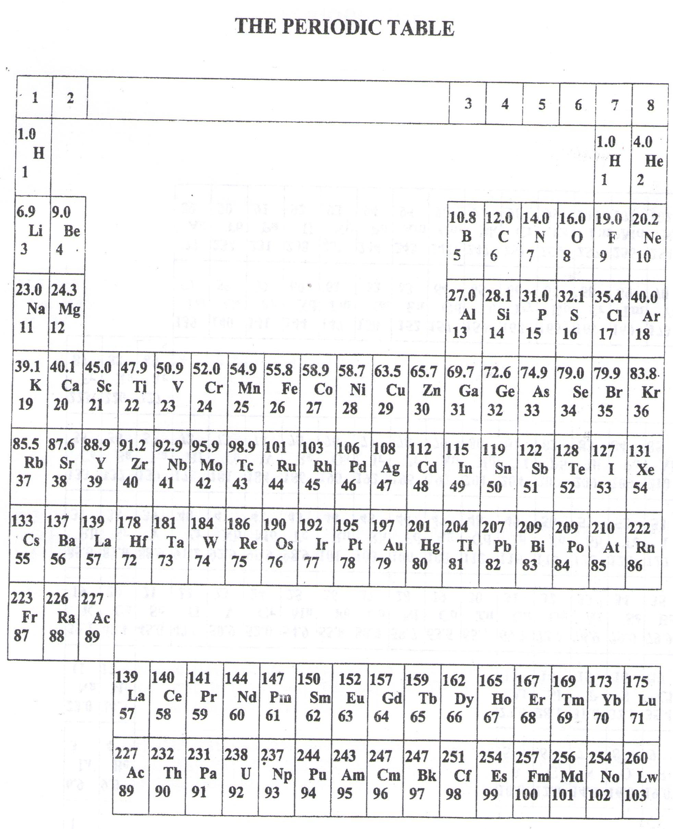

- ===END===
WELCOME TO SENIOR SIX, YEAR 2023
This is the last page of the printed paper, Page 07

